

Lab challenge

Info-6009



November 4, 2019

bohan zhang

0814917

# Index

* **Introduction**
* **Scope**
* **Identify Vulnerabilities and Proof of Concept (PoC)**
* **Conclusion**
* **Reference**

# 

# Introduction

Metasploitable 2 is a test environment developed and distributed by Rapid7. Metasploitable2 designed for security researcher and professionals to practice penetration testing and doing security research.

This penetration test carried out by Bohan Zhang in total 1 day. The purpose of this test is to use machine’s vulnerabilities to gain access and root it. The test identified and used Remote Code Execution in DistCC and Linux SUID in older version Nmap 4.5.3 to carry out and root the machine.

DistCC is a source code (C / C++) remote compile distribution software allows distributing the source code builds in a network. The advantage with this software is speedup the compilation and distribution to multiple machines at same time. However, because the trust relationship established in a computer network, the DistCC server completely trust its client so this allows an attacker to remotely run arbitrary code(RCE) from the client to the server.

Nmap 4.53 has a interactive mode which opens a shell. However, due to the misconfiguration, In this machine, Nmap 4.53 set to use SUID which allows a program run with the root privilege when necessary. This allows an attacker to use the Nmap interactive mode popup a root shell.

# Scope

* DistCC Source Code / Documentation: <https://distcc.github.io/> <https://github.com/distcc/distcc>
* Nmap 4.53

# Testing Environment

Kali(Light) Linux 64bits

# Identify Vulnerabilities and PoC

The following section lists found vulnerabilities. Each vulnerability has been assigned an unique Id. The order of vulnerabilities is not listed based on their severity order instead of in a chronological order, which leads to the Root.

## Metaspolitable-001

The DistCC program vulnerability allows an attacker to breach the trust established between the client and server and run RCE to gain access. Based on OpenVAS vulnerability scanner, the severity is High 8.5/10. Base Vector: AV: N AC:L Au: N C:P I:N A:C

POC:

Pre-discover:

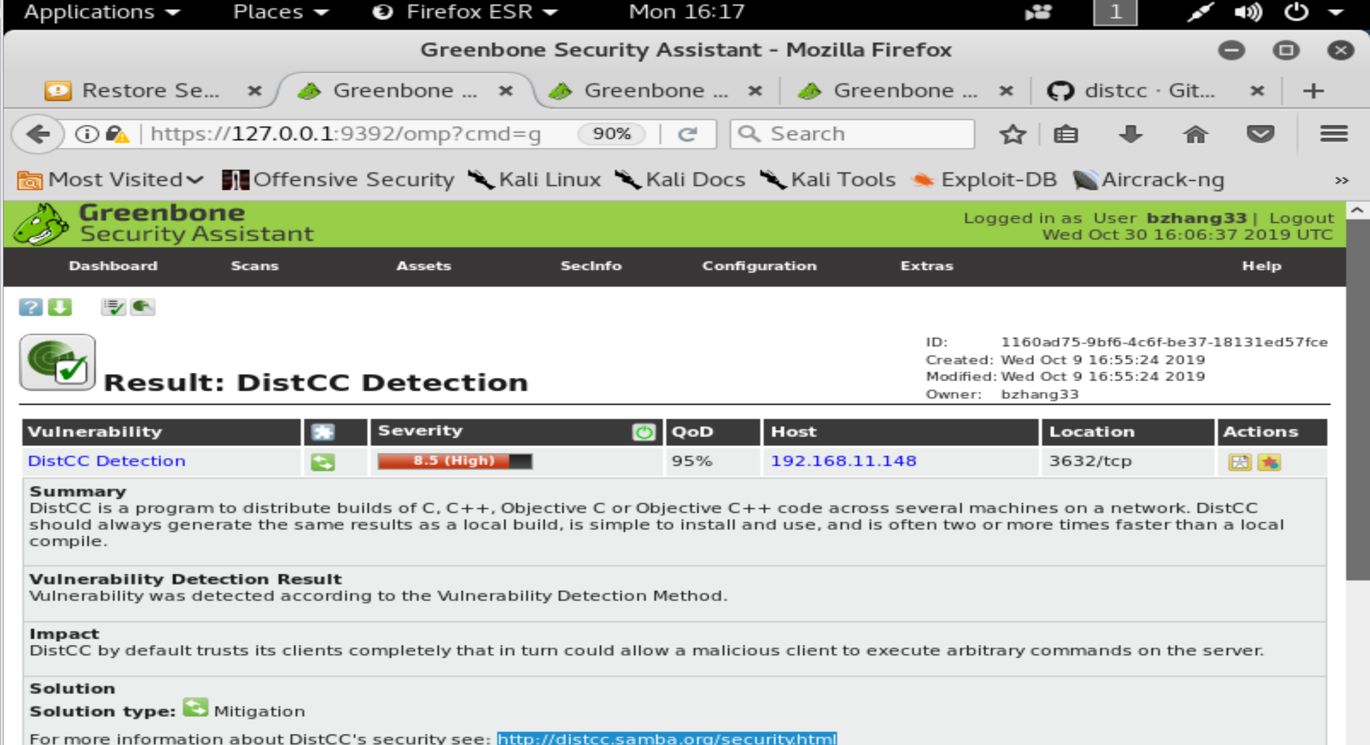

Step1:

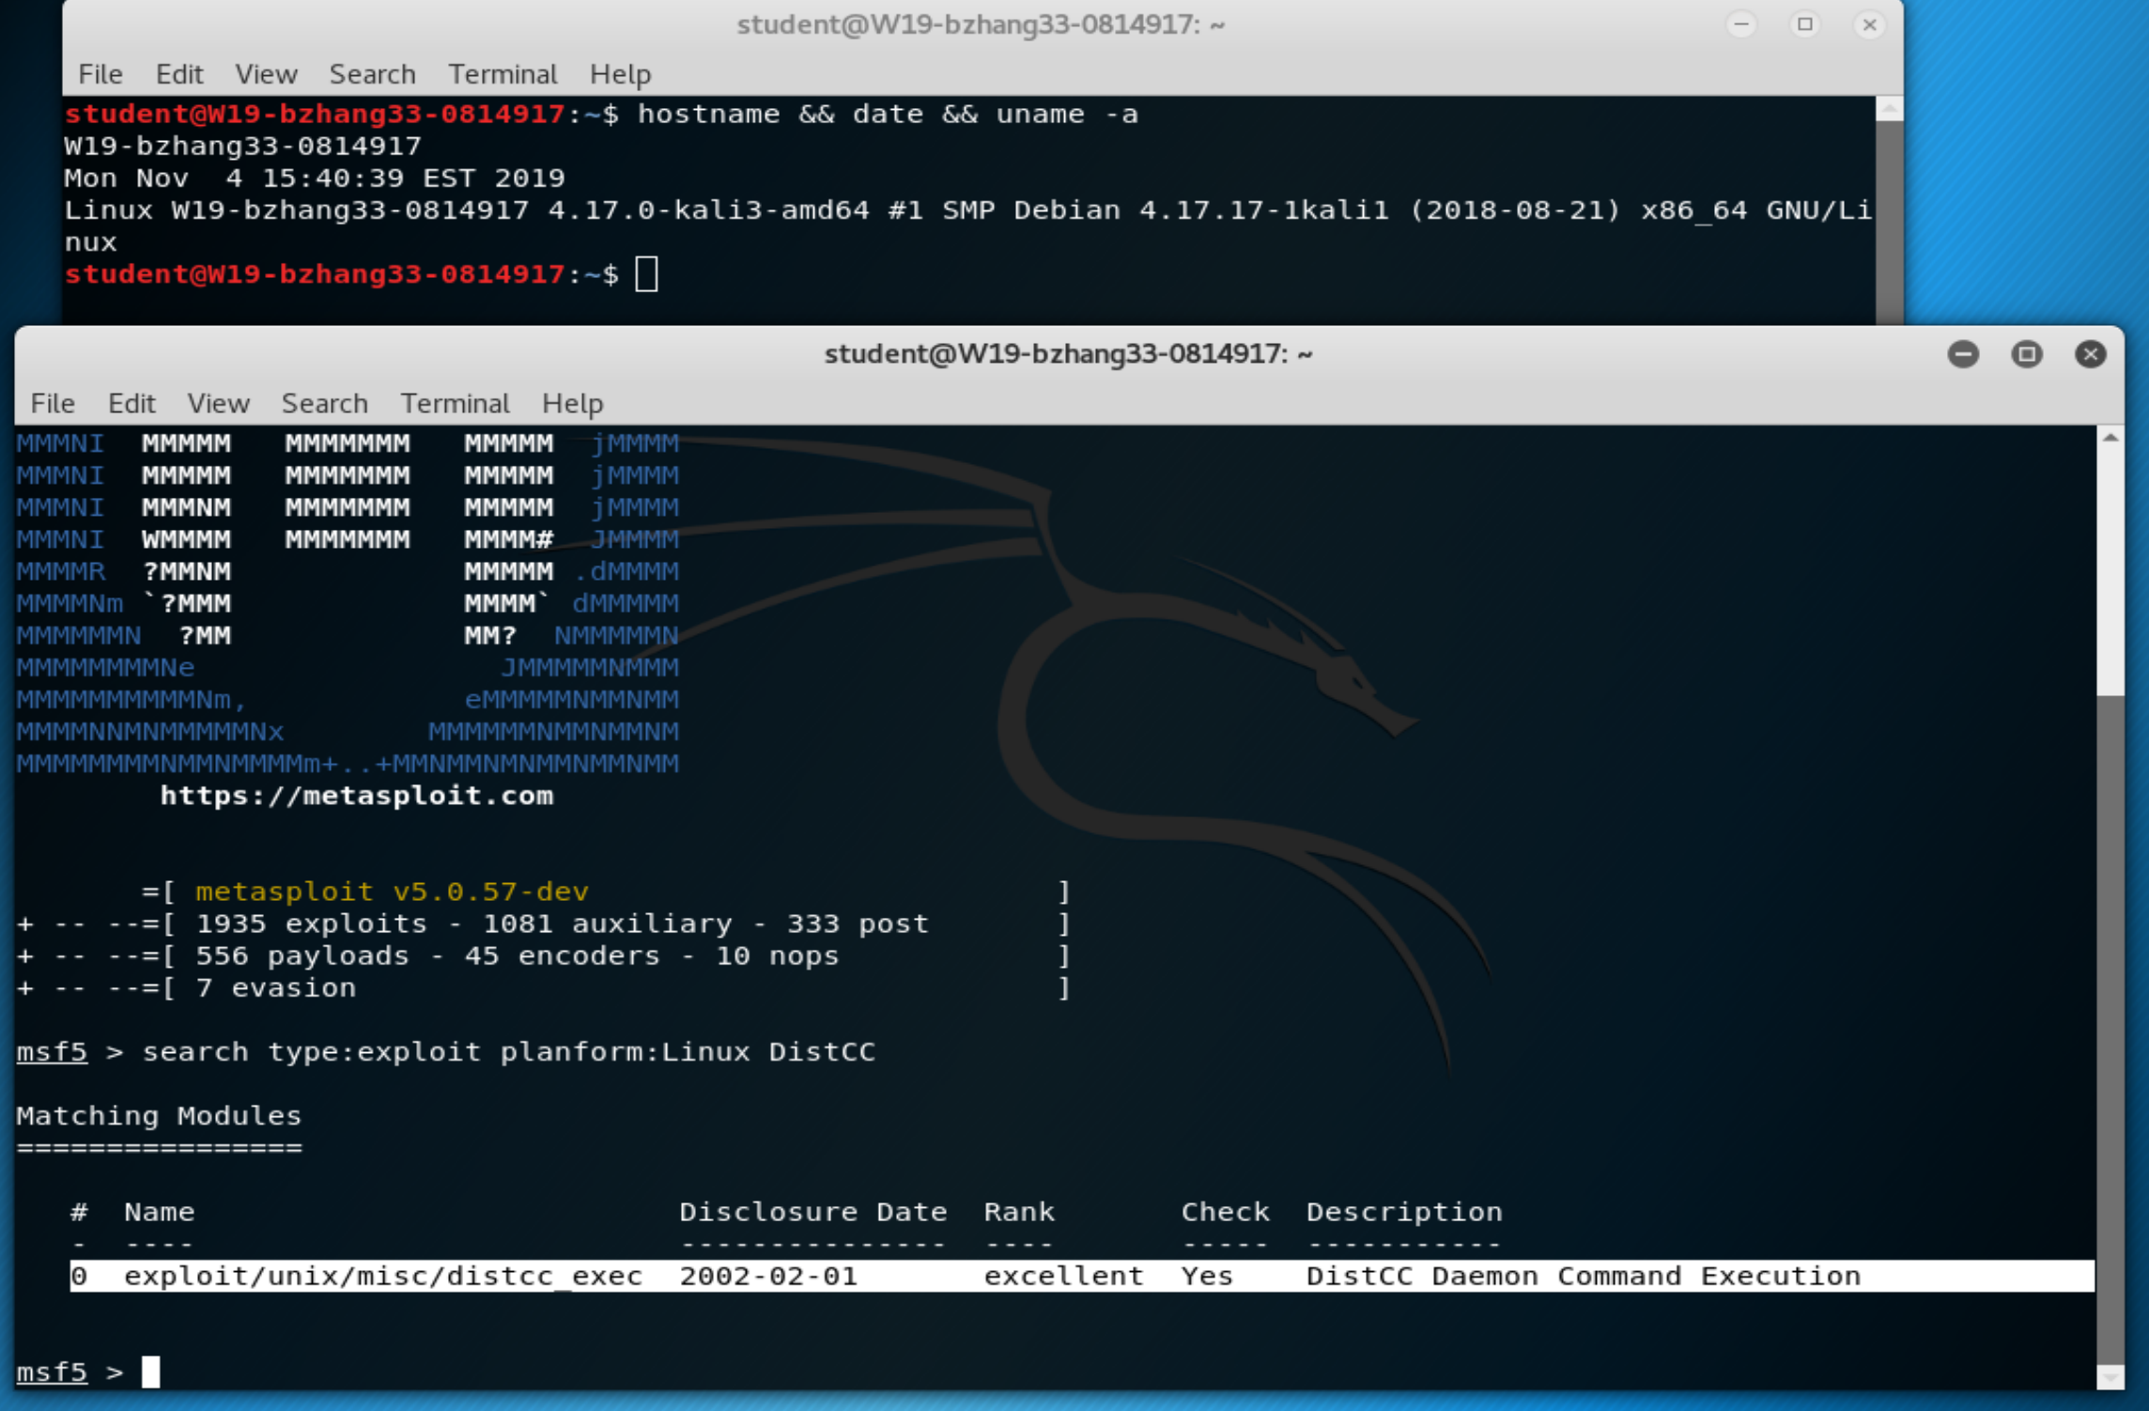

Step2:

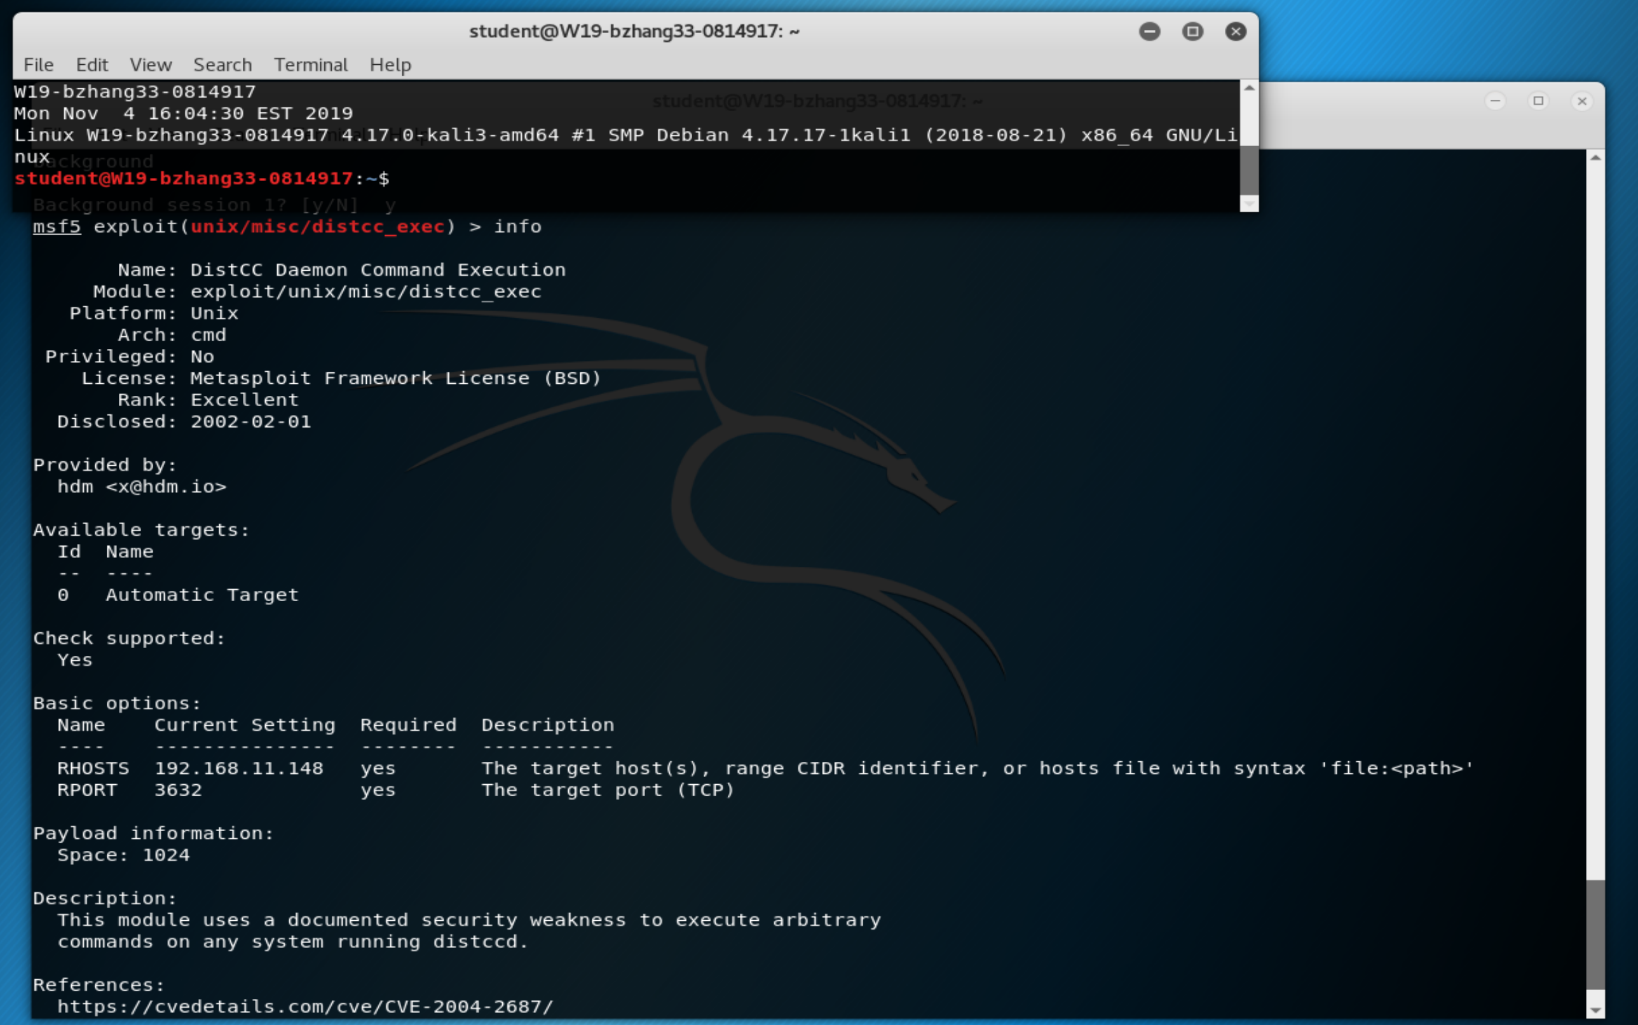

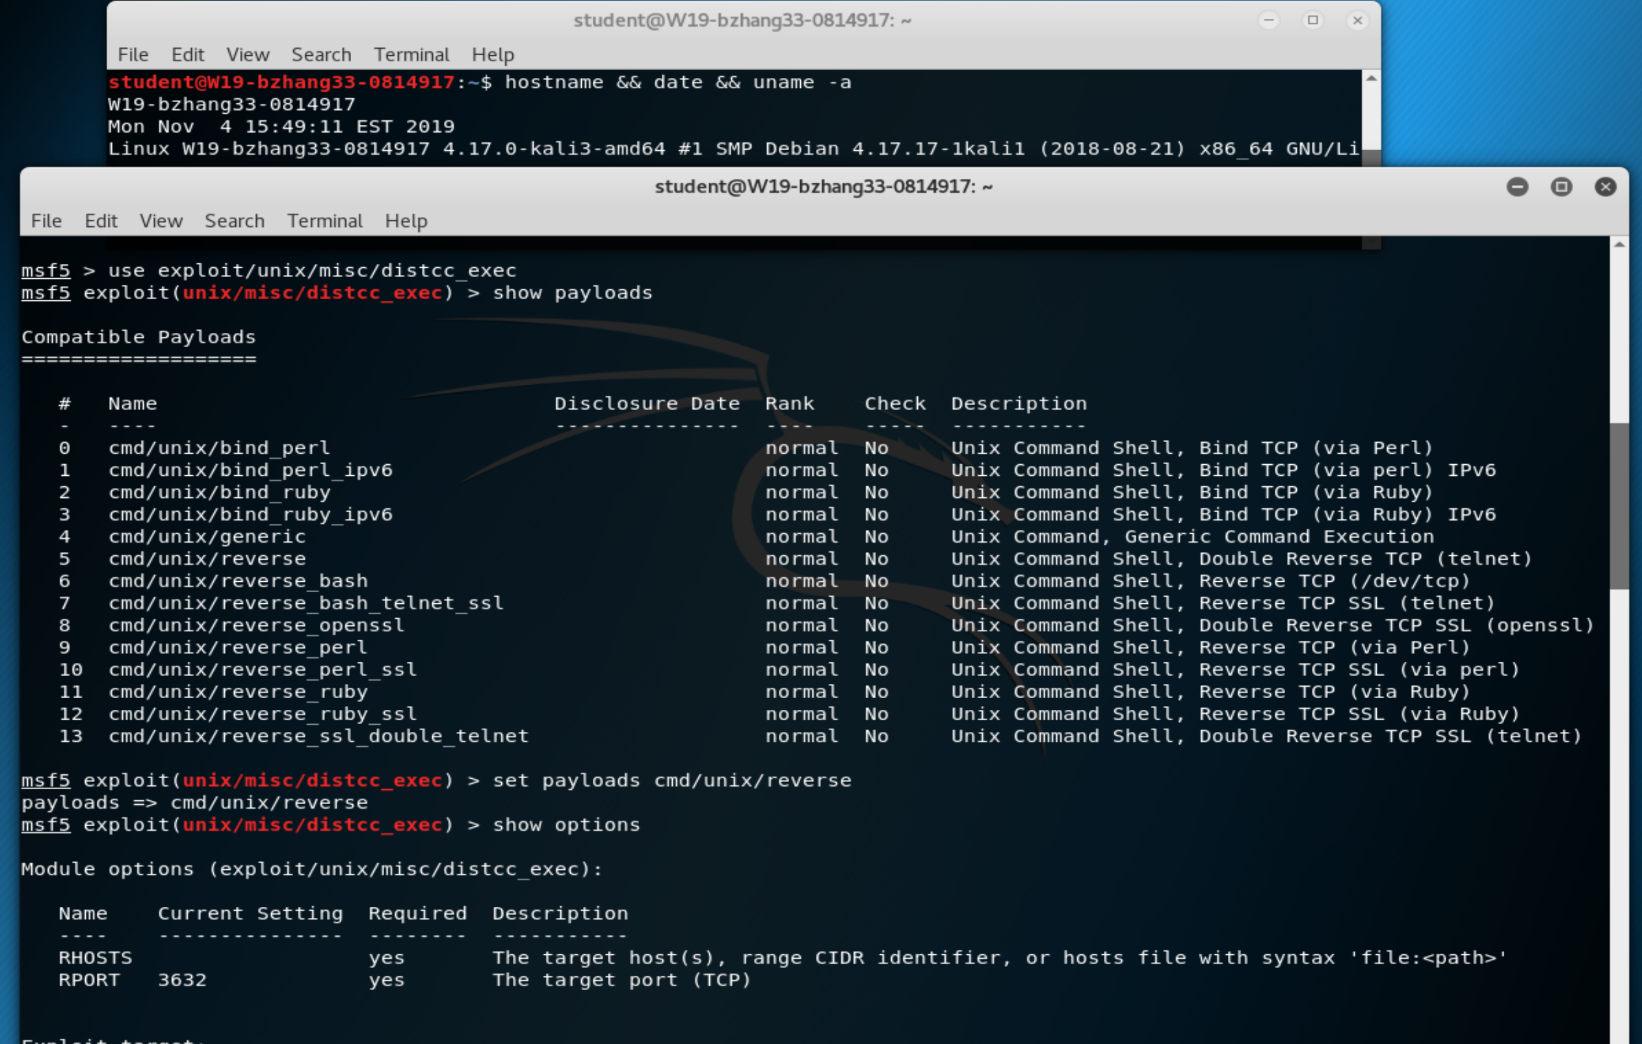

Step3 :

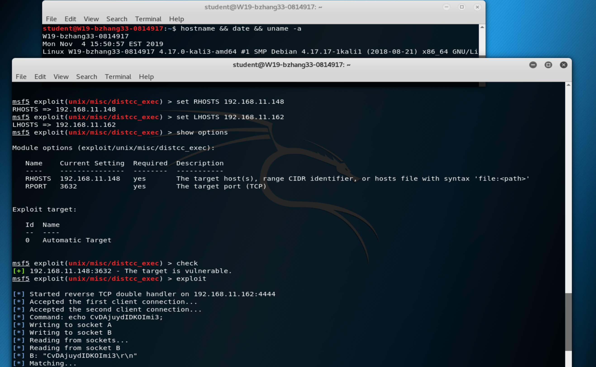

Step4(Gaining Access as a daemon user):

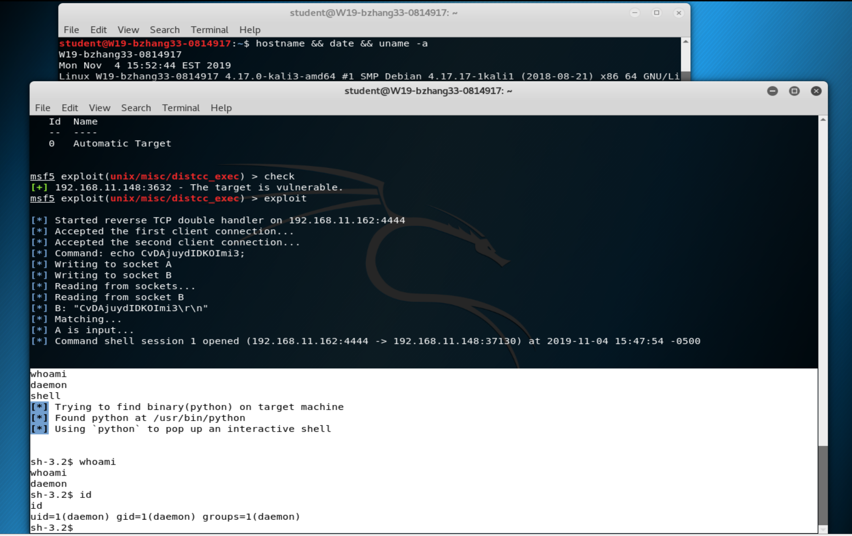

Mitigation:

Since the established trust relationship breached between the client and server, use firewall or –allow option on DistCC to limit access to port 3632 and use SSH to access DistCC will mitigate this vulnerability.

## Metasploitable2-002

The Nmap 2.02 to 5.21 has an interactive mode. In this machine, since the Nmap is 4.53 and set to use SUID which allows the user to run the interactive shell with the root privilege.

Step1:

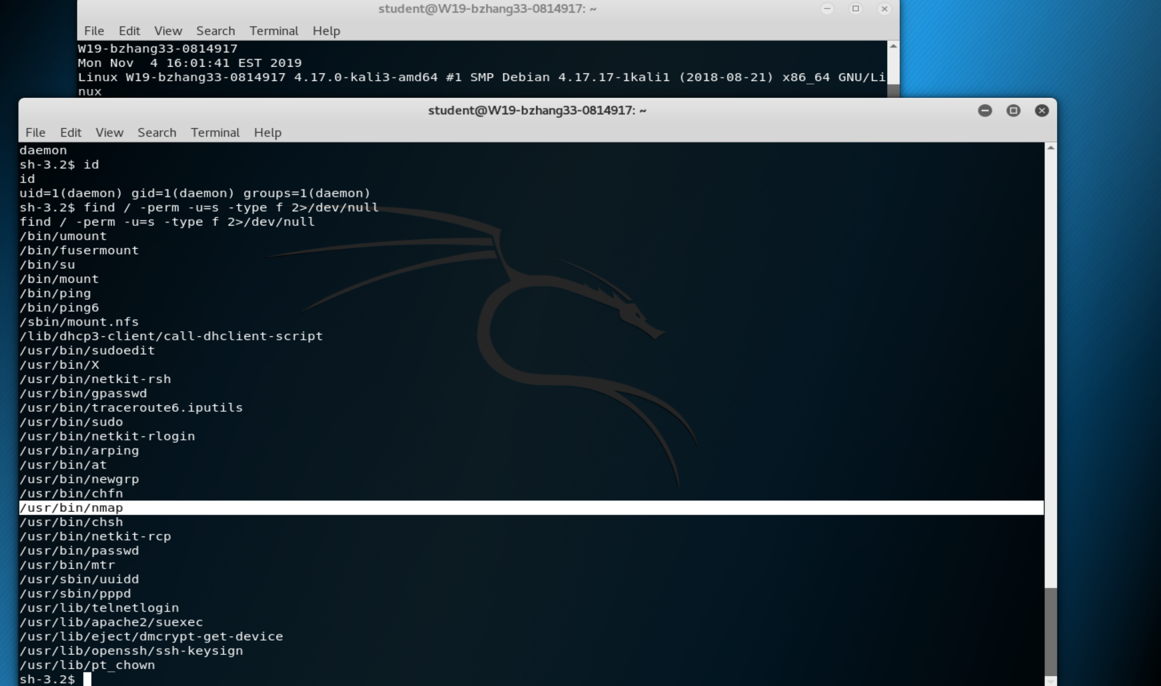

Step2:

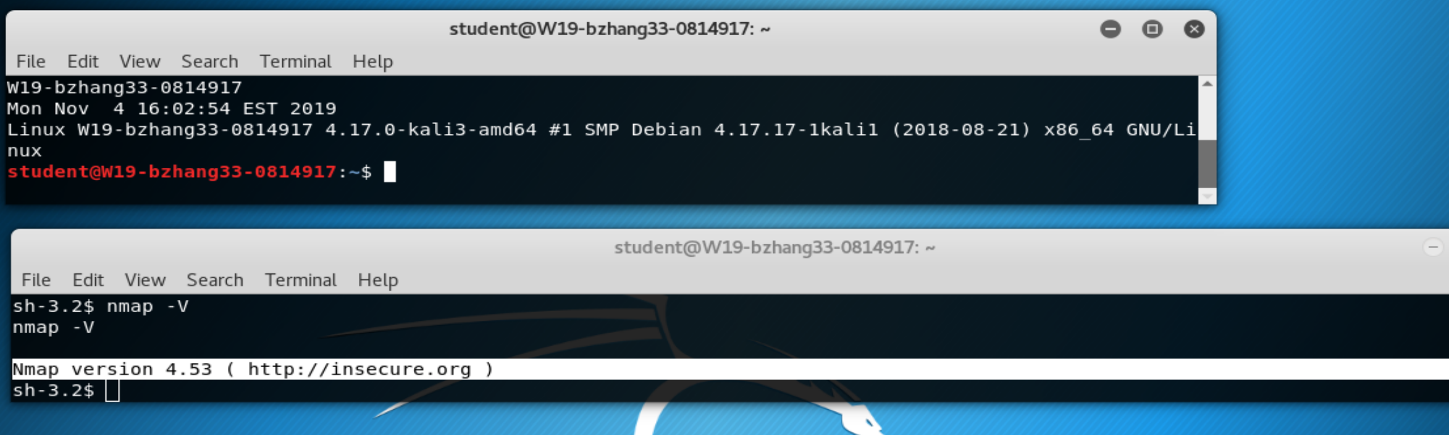

Step3:

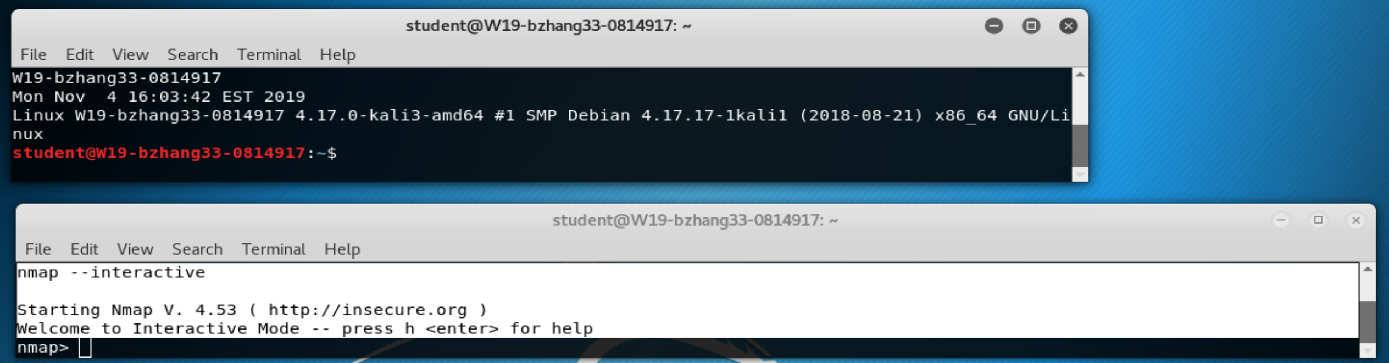

Step4(Gaining the Root):

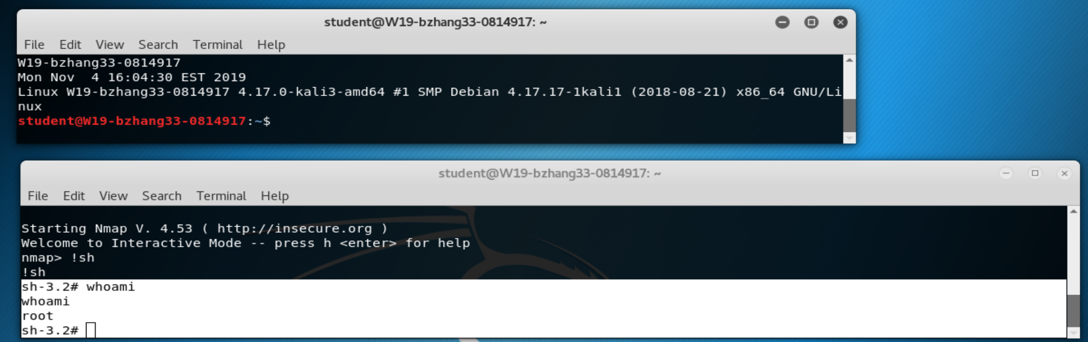

Mitigation:

Since the Nmap 4.53 has an interactive mode which leads to vulnerability, the best way to mitigate the risk is to upgrade the Nmap to 7.80. The second option but less preferred is to unset the SUID on Nmap 4.53 if the upgrading is not possible.

# Conclusion

The RCE on the DistCC should be addressed as soon as possible. The vulnerability is easy to exploit and allows attacker to exploit over network, which made it even more concerned. Restrict port 3632 and use SSH tunnel to access DistCC would be the best option I recommend. Besides the RCE on the DistCC, upgrading the Nmap or unset the SUID on it is another thing should be considered as soon as possible.

# Reference

1. “distcc security notes”, <https://distcc.github.io/security.html>
2. “SUID Executables”, *Penetration Testing Lab*, https://pentestlab.blog/category/privilege-escalation/